List of stereotye to categorize subProfiles ShortCircuit Description Operation European Abstract Entsoe

Concrete Classes

CAEcEcoDuSnEtinnegrPgoy iSnht aring Reference Data Market Document assembly
model
An administrative point where Energy Supplier change can take place and for which commercial business
processes are defined.

Native Members

administrativeStatus 0..1 String Specifies whether (or not) the AccountingPoint is active part of the imbalance settlement. Additional information: E.g., if still physically connected, but inactive in the market, the energy volume for the AccountingPoint will be part of the losses in the grid.

energySharingEnergyDirection 0..1 String The Energy flow direction used in the Collective energy sharing process.

energySharingParticipationFactor 0..1 Integer A value from 1 to 100, where 100 is the default value determining zthe participation of the final customer in the Collective En ergy Storing Unit (CESU).
Lower values enable final customers to participate in more than one CESU.

flexibilityContract 0..1 Boolean Indicates if there are contract(s) at this Accounting Point as a result of the demand side management or the load management for the Accounting Point.

gridAgreementType | 0..1 | String | Specification of type of grid contract, such as if the contract is directly between the Grid Company and the Grid Customer, or through the Energy Supplier.
meterReadingResolution | 0..1 | Duration | The length of time between the regular meter readings.
mRID | 0..1 | MeasurementPointID_String | A unique identification
of the measurement point.

 |  |  | In the ESMP context, the "model authority" is defined as an authorized issuing office that provides an agreed identification coding scheme for market participant, domain, measurement point, resources (generator, lines, substations, etc.) identification.
Master resource identifier issued by a model authority. The mRID is globally unique within an exchange context.
Global uniqueness is easily achieved by using a UUID for the mRID. It is strongly recommended to do this.
For CIMXML data files in RDF syntax, the mRID is mapped to rdf:ID or rdf:about attributes that identify CIM object elements.
settlementMethod | 0..1 | String | Specifies how the energy volumes are treated for settlement for the AccountingPoint, such as profiled or non-

profiled.

CAEsEseDtS Energy Sharing Reference Data Market Document assembly
model
asset is an energy data space specific attribute referring to the Asset from which data is being requested

Native Members

meterId 0..1 String meterId is an energy data space specific attribute that specifies the id of the meter that measures the asset.

operatorId 0..1 String operatorId is an energy data space specific attribute that specifies the id operator of the asset refered to.

type 0..1 String type is an energy data space specific attribute that specifies type of asset refered to.

CEEnEerDgSyCEonmermgyuSnhitayring Reference Data Market Document assembly
model
Native Members
DateFrom | 0..1 | ESMP_DateTime
mRID | 0..1 | String | Master resource identifier issued by a model authority. The mRID is unique within an exchange context. Global uniqueness is easily achieved by using a UUID, as specified in IETF RFC 4122, for the mRID. The use of UUID is strongly recommended.  For CIMXML data files in RDF syntax conforming to IEC 61970- 552, the mRID is mapped to rdf:ID or rdf:about attributes that identify CIM object elements.

CEESERDDSMEDn_eErngvyeSlohpareing Reference Data Market Document assembly
model
The envelope entity is a non-CIM object used in an energy data space environment to serve as a central top-
level entity connecting the MarketDocumentHeader (energy data space specific context information block) with

the regular CIM MarketDocument.

Native Members
MarketDocument
[0..1]
ESRDMD_MarketDocument
MessageDocumentHeader
[0..1]
MessageDocumentHeader

CEESERDDSMEDn_eMrgayrkSehtDaroincgumReefnetrence Data Market Document assembly
model
An electronic document containing the information necessary to satisfy the requirements of a given business
process.

Native Members
createdDateTime | 0..1 | ESMP_DateTime | The date and time of the creation of the document.
description | 0..1 | String | The description is a free human readable text describing or naming the object. It may be non unique and may not correlate to a naming hierarchy.
mRID | 0..1 | ID_String | The unique identification of the document being exchanged within a business process flow.  In the ESMP context, the "model authority" is defined as a party (originator of the exchange) that provides an identification in the context of a business exchange such as document identification, ...

Master resource identifier issued by a model authority. The mRID is globally unique within an exchange context.
Global uniqueness is easily achieved by using a UUID for the mRID. It is strongly recommended to do this.
For CIMXML data files in RDF syntax, the mRID is mapped to rdf:ID or rdf:about attributes that identify CIM object elements.

receiver_MarketParticipant.marketRole.type 0..1 MarketRoleKind_String The identification
of the role played by a market player.

--- The MarketParticipant associated with an electronic document header.
--- The role associated with a MarketParticipant.

receiver_MarketParticipant.mRID 0..1 PartyID_String The identification
of a party in the energy market.

In the ESMP context, the "model authority" is defined as an authorized issuing office that provides an agreed identification coding scheme for market participant, domain, measurement

point, resources (generator, lines, substations, etc.) identification.

Master resource identifier issued by a model authority. The mRID is globally unique within an exchange context.
Global uniqueness is easily achieved by using a UUID for the mRID. It is strongly recommended to do this.
For CIMXML data files in RDF syntax, the mRID is mapped to rdf:ID or rdf:about attributes that identify CIM object elements.
--- The MarketParticipant associated with an electronic document header.

receiver_MarketParticipant.name 0..1 String The name is any
free human readable and possibly non unique text naming the object.
--- The MarketParticipant associated with an electronic document header.

revisionNumber 0..1 ESMPVersion_String The identification of the version that distinguishes one evolution of a document from another.

sender_MarketParticipant.marketRole.type 0..1 MarketRoleKind_String The identification

of the role played by a market player.

--- The MarketParticipant associated with an electronic document header.
--- The role associated with a MarketParticipant.

sender_MarketParticipant.mRID 0..1 PartyID_String The identification
of a party in the energy market.

In the ESMP context, the "model authority" is defined as an authorized issuing office that provides an agreed identification coding scheme for market participant, domain, measurement point, resources (generator, lines, substations, etc.) identification.

Master resource identifier issued by a model authority. The mRID is globally unique within an exchange context.
Global uniqueness is easily achieved by using a UUID for the mRID. It is strongly recommended to do this.
For CIMXML data files in RDF syntax, the mRID is mapped to rdf:ID or rdf:about attributes that

.
identify CIM object elements.
--- The MarketParticipant associated with an electronic document header
sender_MarketParticipant.name | 0..1 | String | The name is any
 |  |  | free human
 |  |  | readable and
 |  |  | possibly non
 |  |  | unique text
 |  |  | naming the
 |  |  | object.
 |  |  | --- The
 |  |  | MarketParticipant
 |  |  | associated with
 |  |  | an electronic
 |  |  | document header
type | 0..1 | MessageKind_String | The coded type of
 |  |  | a document. The
 |  |  | document type
 |  |  | describes the
 |  |  | principal
 |  |  | characteristic of
 |  |  | the document.

.

CMEeEsDsaSgEenDeorcguymSehnartiHnegaRdeefrerence Data Market Document assembly
model
MessageDocumentHeader is an energy data space specific entity with the creationDateTime of this document.

Native Members

creationDateTime 0..1 ESMP_DateTime The date and time the
MessageDocumenHeader was created.

MetaInformation [0..1] MetaInformation

CMEeEtaDInSfoErnmeragtyioSnharing Reference Data Market Document assembly
model
MetaInformation is an energy data space specific entity referring to the information concerning the technical and
functional context of the MarketDocument.

Native Members

connectionId 0..1 String connectionId is an energy data

 |  |  | space specific attribute referring to the established connection used for the communication of this document.
dataNeedId | 0..1 | String | dataNeedId is an energy data
 |  |  | space specific attribute holding
 |  |  | the type of data need requested,
 |  |  | like ‘last 24 hours at 1 hour
 |  |  | interval”.
dataSourceId | 0..1 | String | dataSourceId is an energy data
 |  |  | space specific attribute referring
 |  |  | to the datasource from which the
 |  |  | requested data is being queried.
defaultValues | 0..1 | String | defaultValues is a energy data
 |  |  | space specific attribute to hold
 |  |  | relevant default values. The
 |  |  | format to use can freely be
 |  |  | chosen based on the
 |  |  | implementation. Most commonly
 |  |  | you would expect a semi-colon
 |  |  | separated name value pair, like:
 |  |  | "minPower=value;
 |  |  | maxPower=value;
 |  |  | avgPower=value".
documentType | 0..1 | String | documentType is an energy data
 |  |  | space specific attribute referring
 |  |  | to the type of document,
 |  |  | comparable to the
 |  |  | MessageTypeList in the CIM part
 |  |  | of the message.
 |  |  | Note:
 |  |  | This is applicable if you have the
 |  |  | need to know the content without
 |  |  | having to open the complete
 |  |  | document. DocumentType might
 |  |  | contain messages not (yet) part
 |  |  | of the MessageTypeList.
finalCustomerId | 0..1 | String | The finalCustomerId is an energy
 |  |  | data space specific attribute
 |  |  | identifying the actor doing the
 |  |  | request for data or data sharing.
regionConnector | 0..1 | String | regionConnector is an energy
 |  |  | data space specific attribute that
 |  |  | specifies the regional connector
 |  |  | being used to retrieve the data
 |  |  | requested.

regionCountry | 0..1 | String | regionCountry is an energy data space specific attribute that specifies the country where the regional connector is located.
requestPermissionId | 0..1 | String | The requestPermissionId is
 |  |  | energy data space specific
 |  |  | identification attribute holding an
 |  |  | unique identifier issued by the
 |  |  | energy data space to allow for
 |  |  | tracing of the permission through
 |  |  | serveral message exchanges.
 |  |  | Note: the requestPermissionId is
 |  |  | NOT the identifier issued by the
 |  |  | Identity Service Provider as
 |  |  | specified in the EU Implementing
 |  |  | Act on access to Metering and
 |  |  | Consumption Data.
Asset | [0..1] | Asset

CMEeEteDrSReEandeirnggy Sharing Reference Data Market Document assembly
model
Set of values obtained from the meter.

Native Members

mRID 0..1 ResourceID_String The unique identification of the meter reading.

In the ESMP context, the "model authority" is defined as a party (originator of the exchange) that provides an identification in the context of a business exchange.

Master resource identifier issued by a model authority. The mRID is unique within an exchange context. Global uniqueness is easily achieved by using a UUID, as specified in RFC 4122, for the mRID. The use of UUID is strongly recommended.
For CIMXML data files in RDF syntax conforming to IEC 61970- 552 Edition 1, the mRID is mapped to rdf:ID or rdf:about attributes that identify CIM object elements.

name 0..1 String The name is any free human readable and possibly non

unique text naming the object.

CPEroEcDeSssEnergy Sharing Reference Data Market Document assembly
model
The formal identification of the business process in which a flow of information is exchanged.

Native Members

classificationType 0..1 ClassificationKind_String The classification mechanism
used to group a set of objects together within a business process. The grouping may be of a detailed or a summary nature.

processType 0..1 ProcessKind_String The identification of the nature of
process that the document addresses.

Enumerations

CodingSchemeTypeList ESMPEnumerations

Codification scheme used to identify the coding scheme used for the set of coded values to identify specific objects.

EIC The coding scheme is the Energy Identification Coding Scheme (EIC), maintained by ENTSO-E.

Coding scheme which are part of GS1 system

The coding schemes maintained by GS1.

Andorra National coding scheme

The National coding scheme of the country in question.

Albania National coding scheme

The National coding scheme of the country in question.

Armenia National coding scheme

The National coding scheme of the country in question.

Austria National coding scheme

The National coding scheme of the country in question.

Azerbaijan National coding scheme

The National coding scheme of the country in question.

Bosnia and Herzegovina National coding scheme
The National coding scheme of the country in question.

Belgium National coding scheme
The National coding scheme of the country in question.

Bulgaria National coding scheme
The National coding scheme of the country in question.

Switzerland National coding scheme
The National coding scheme of the country in question.

Serbia and Montenegro National coding scheme
The National coding scheme of the country in question.

Czech Republic National coding scheme
The National coding scheme of the country in question.

Germany National coding scheme
The National coding scheme of the country in question.

Denmark National coding scheme
The National coding scheme of the country in question.

Estonia National coding scheme
The National coding scheme of the country in question.

Spain National coding scheme
The National coding scheme of the country in question.

Finland National coding scheme
The National coding scheme of the country in question.

France National coding scheme
The National coding scheme of the country in question.

United Kingdom National coding scheme
The National coding scheme of the country in question.

Georgia National coding scheme
The National coding scheme of the country in question.

Gibraltar National coding scheme
The National coding scheme of the country in question.

Greece National coding scheme
The National coding scheme of the country in question.

Croatia National coding scheme
The National coding scheme of the country in question.

Hungary National coding scheme
The National coding scheme of the country in question.

Ireland National coding scheme
The National coding scheme of the country in question.

Italy National coding scheme
The National coding scheme of the country in question.

Kyrgyzstan National coding scheme
The National coding scheme of the country in question.

Kazakhstan National coding scheme
The National coding scheme of the country in question.

Liechtenstein National coding scheme
The National coding scheme of the country in question.

Lithuania National coding scheme
The National coding scheme of the country in question.

Luxembourg National coding scheme
The National coding scheme of the country in question.

Latvia National coding scheme
The National coding scheme of the country in question.

Morocco National coding scheme
The National coding scheme of the country in question.

Moldavia National coding scheme
The National coding scheme of the country in question.

Macedonia National coding scheme
The National coding scheme of the country in question.

Netherlands National coding scheme
The National coding scheme of the country in question.

Nordic Regional coding scheme
The coding scheme of the Nordic region which covers Denmark, Finland, Norway and Sweden.

Norway National coding scheme
The National coding scheme of the country in question.

Poland National coding scheme
The National coding scheme of the country in question.

Portugal National coding The National coding scheme of the country in question.

scheme

Romania National coding scheme

The National coding scheme of the country in question.

Russian Federation National coding scheme

The National coding scheme of the country in question.

Sweden National coding scheme

The National coding scheme of the country in question.

Slovenia National coding scheme

The National coding scheme of the country in question.

Slovakia National coding scheme

The National coding scheme of the country in question.

Turkey National coding scheme

The National coding scheme of the country in question.

Ukraine National coding scheme

The National coding scheme of the country in question.

CGM The coding scheme used for Common Grid Model Exchange Standard (CGMES).

Cyprus National coding scheme

The National coding scheme of the country in question.

ISO The coding scheme for the preceding attribute is a code maintained by International Organization for Standardization (ISO), such as “ISO 3166 English country names and code elements”.

RoleTypeList
Identification of the role played by a party.
ESMPEnumerations
Trade responsible party
Refer to role model definitions in the ENTSO-E Harmonised Role Model Document.
Consumption responsible party
Refer to role model definitions in the ENTSO-E Harmonised Role Model Document.
Combined power exchange (not to be used)
This role is no longer in the ENTSO-E Harmonised Role Model Document.
System operator
Refer to role model definitions in the ENTSO-E Harmonised Role Model

Imbalance settlement responsible
Refer to role model definitions in the ENTSO-E Harmonised Role Model Document.

Production responsible party
Refer to role model definitions in the ENTSO-E Harmonised Role Model Document.

Transmission capacity allocator
Refer to role model definitions in the ENTSO-E Harmonised Role Model Document.

Balance responsible party
Refer to role model definitions in the ENTSO-E Harmonised Role Model Document.

Metered data aggregator Refer to role model definitions in the ENTSO-E Harmonised Role Model
Document.

Billing agent Refer to role model definitions in the ENTSO-E Harmonised Role Model
Document.

Market operator Refer to role model definitions in the ENTSO-E Harmonised Role Model
Document.

Energy supplier Refer to role model definitions in the ENTSO-E Harmonised Role Model
Document.

Consumer Refer to role model definitions in the ENTSO-E Harmonised Role Model Document.

Control area operator Refer to role model definitions in the ENTSO-E Harmonised Role Model
Document.

Control block operator Refer to role model definitions in the ENTSO-E Harmonised Role Model
Document.

Coordination centre operator
Refer to role model definitions in the ENTSO-E Harmonised Role Model Document.

Grid access provider Refer to role model definitions in the ENTSO-E Harmonised Role Model
Document.

Grid operator Refer to role model definitions in the ENTSO-E Harmonised Role Model
Document.

Meter administrator Refer to role model definitions in the ENTSO-E Harmonised Role Model

Party connected to grid Refer to role model definitions in the ENTSO-E Harmonised Role Model
Document.

Producer Refer to role model definitions in the ENTSO-E Harmonised Role Model Document.

Profile maintenance party
Refer to role model definitions in the ENTSO-E Harmonised Role Model Document.

Meter operator Refer to role model definitions in the ENTSO-E Harmonised Role Model
Document.

Metered data collector Refer to role model definitions in the ENTSO-E Harmonised Role Model
Document.

Metered data responsible Refer to role model definitions in the ENTSO-E Harmonised Role Model
Document.

Metering point administrator
Refer to role model definitions in the ENTSO-E Harmonised Role Model Document.

Resource Provider Refer to role model definitions in the ENTSO-E Harmonised Role Model
Document.

Scheduling coordinator Refer to role model definitions in the ENTSO-E Harmonised Role Model
Document.

Capacity Trader Refer to role model definitions in the ENTSO-E Harmonised Role Model
Document.

Interconnection Trade Responsible
Refer to role model definitions in the ENTSO-E Harmonised Role Model Document.

Nomination Validator Refer to role model definitions in the ENTSO-E Harmonised Role Model
Document.

Market information aggregator
Refer to role model definitions in the ENTSO-E Harmonised Role Model Document.
A party that collects information from different sources and assembles it to provide a summary of the market.

Information receiver Refer to role model definitions in the ENTSO-E Harmonised Role Model
Document.
A party, not necessarily a market participant, which receives information

about the market.

Reserve Allocator Refer to role model definitions in the ENTSO-E Harmonised Role Model
Document.
A party that informs the market of reserve requirements, receives tenders against the requirements and in compliance with the prequalification criteria, determines what tenders meet requirements and assigns tenders.

MOL Responsible Refer to role model definitions in the ENTSO-E Harmonised Role Model
Document.
A party that Informs the market of reserve requirements, receives tenders against the requirements and in compliance with the prequalification criteria, determines what tenders meet requirements and assigns tenders.

Capacity Coordinator A party, acting on behalf of the SOs involved, responsible for establishing a
coordinated Offered Capacity and/or NTC and/or ATC between several Scheduling Areas.

Reconciliation Accountable
Refer to role model definitions in the ENTSO-E Harmonised Role Model Document.
A party that is financially accountable for the reconciled volume of energy products for a profiled local metering point.

Reconciliation Responsible
A party that is responsible for reconciling, within a metering grid area, the volumes used in the imbalance settlement process for profiled metering points and the actual metered quantities.

Data provider A party that is responsible for providing information to a central authority.

Local Issuing Office (LIO)
A party that is responsible for operating a Local Issuing Office (LIO).

Central Issuing Office (CIO)
A party that is responsible for operating a Central Issuing Office (CIO).

EIC Participant A party that participates in the EIC environment.

Weather analyser A party that analyses the current and forecast weather situation and
establishes a prognosis of its impact on the renewable energy environment as well as the overall load.

Regional Security Coordinator (RSC)
The RSC as defined in the System Operation guideline.

Energy Service Company (ESCO)
A party offering energy-related services to the Party Connected to Grid, but not directly active in the energy value chain or the physical infrastructure itself. The ESCO may provide insight services as well as energy management services.

Balancing Service Provider
A party with reserve-providing units or reserve-providing groups able to provide balancing services to LFC Operators.

Energy trader A party that is selling or buying energy.

LFC Operator A party that is responsible for the Load Frequency Control of its LFC Area or
LFC Block.

Transmission System Operator (TSO)

The Transmission System Operator (TSO) is responsible for the transport of electricity on the extra high-voltage and high-voltage interconnected system. This is a market participant and not a role in Harmonised Role Model.

Distribution System Operator (DSO)

Distribution System Operator (DSO) is responsible for transport of electricity on high-voltage (optionally), medium-voltage and low-voltage distribution systems. This is a market participant and not a role in Harmonised Role Model.

Resource Capacity Mechanism Operator

Resource capacity mechanism operator is the party responsible to operate the resource capacity mechanism in a member state. It can either be the TSO or an independent party.

Resource aggregator A party that aggregates resources for usage by a service provider for energy
market services.

Cost sharing calculator A party responsible for the mapping of the costs between areas and parties.

Settlement responsible A party responsible for settling the costs.

Coordinated Capacity Calculator

Coordinated Capacity Calculator is the entity or entities with the task of calculating transmission capacity, at regional level or above.

Flexibility service provider

A party that offers flexibility services based on acquired (aggregated) resources.

Data access provider A party responsible for facilitating access to data.

Metered data administrator

A party responsible for storing and distributing validated measured data.

Permission administrator A party responsible for administrating a register of data access permissions
for a set of metering points, making this information available to final customers and eligible parties in the sector, on request.

MessageTypeList
ESMPEnumerations

The coded type of a document. The message type describes the principal characteristic of a document. This enumeration is used in the XML instances based on IEC 62325.

Balance responsible schedule
A schedule which has been prepared by a balance responsible party providing planned schedule information.

Allocated capacity schedule
A schedule which has been prepared by a capacity allocator providing allocated capacity.

Balance area schedule A schedule that provides the planned schedule information for a balance
area.

System Operator area schedule
A compilation of all external schedules concerning two System Operator areas or a connector concerning two System Operator of all balance responsible parties.

Control block area schedule
A compilation of all the exchange programs of all control areas for one control block with all neighbouring control areas of a neighbouring control block.

Coordination center area schedule
A compilation of the exchange programs of all exchange blocks divided into UCTE south and north.

Intermediate confirmation report
An intermediate confirmation report that may be produced between final cutoffs.

Final confirmation report
A final confirmation report that is produced after a final cutoff.

Finalised schedule A compilation of a set of schedules that have been finalized after a given
cutoff.

Regulation data report A compilation of the time series employed on a given day to ensure the
balance of the system.

Aggregated energy data report
A compilation of the time series of all the meter readings or their equivalent for a given period.

Imbalance report The report containing the complete situation of a given period for a party and
including the schedules, regulation data and actual or calculated readings.

Interconnection Capacity Document for cross-border capacity exchanges.

Resource Provider Resource Schedule
A document providing the schedules for resource objects submitted by a resource provider.

Acquiring System Operator Reserve Schedule
A document providing reserve purchases submitted by an Acquiring System Operator.

Anomaly Report A document providing anomaly information for the receiving party to correct.

Acknowledgement Document A document providing acknowledgement information.

Confirmation report A document providing confirmation information.

Capacity for Resale A document providing information about capacity for resale.

Approved Capacity Transfer
A document to approve a capacity transfer.

Capacity transfer notification
A document notifying a capacity transfer.

Transmission rights portfolio
A document providing the portfolio of the transmission capacity rights of a market participant.

Allocations A document providing the capacity allocations for a border.

Bid document A document providing bid information.

Allocation result document
A document providing the allocation results of an auction.

Capacity document A document providing capacity information.

Rights document A document providing transmission capacity rights information.

Generation availability schedule
This document contains information related to energy availability.

Cross border schedule This document contains the cross border schedules for all the borders of a
given country where energy is exchanged.

Agreed capacity The capacity agreed between parties.

Proposed capacity The capacity proposed for agreement between parties.

System vertical load The sum of all flows out of the transmission grid via directly connected
transformers and lines to distribution grids and end consumers as known by the System Operator.

Escalation document A document which requesting the escalation of a situation.

Trouble shooting document
A document providing trouble shooting information for the resolution of a problem.

Deactivation document A document providing deactivation information.

Reserve tender document The document that is used for the tendering for reserves within the ERRP
process.

Reserve Allocation Result Document
The document used to provide the results of a Reserve auction.

SATCR activation The document is used to provide the activation of reserves through the
SATCR process.

DATCR activation The document is used to provide the activation of reserves through the
DATCR process.

Activation response The document is used to provide a response to a request to activate
reserves.

Tender reduction The document is used to provide information concerning the reduction of a
previously submitted tender.

MOL Document The document is used to provide Merit Order List information.

Price Document The document is used to provide market price information.

Measurement Value Document
The document is used to provide measurement information from measurement devices.

SOAM Document The document is used to provide system operator accounting data for
matching.

SOVA Document The document is used to provide system operator validated accounting data.

CCVA Document The document is used to provide coordination center validated accounting
data.

Daily settlement document
The document is used to provide daily settlement information.

Weekly settlement The document is used to provide weekly settlement information.

document

Capacity Auction Specification Document
The document is used to provide capacity auction specification information.

Market Coupling Results Document
The document is used to provide the results of a market coupling auction.

Outage publication Document
The document is used to provide the outage information for publication.

Forced generation outage Document
A document providing information on forced generation outages.

Summarised Market Schedule
A compilation of all external schedules concerning two Market Balance Areas of all balance responsible parties.

Compensation Program Schedule
A schedule that provides the schedule information for the compensation of unintended deviation.

Load Frequency Control Program Schedule
A schedule that provides the schedule information for the Load Frequency Control Program of a Control Area or a Control Block.

Timeframe Independent Schedule
A compilation of all external Timeframe Independent Schedules concerning two System Operators.

Information request An information request being made concerning some specific information.

status request for a position independently from a specific process
A status request concerning the position of an object independently of any ongoing processes.

Estimated Net Transfer Capacity
The estimated net transfer capacity for a given border.

Compensation rights The capacity rights that have been allocated as compensation.

Redispatch notice A notice to confirm the actions agreed between System Operators to resolve a congestion situation through redispatch.

Tender reduction response
A response to a tender reduction request that provides corrections to the initial document.

System total load Total load', including losses without power used for energy storage, is equal
to generation deducted with exports, added with imports and deducted with power used for energy storage.

Final MOL A document providing the information concerning the situation of the MOL at the end of an activation period.

Resource Provider Schedule for production/consumption
A document providing the schedules for production/consumption for resource objects submitted by a resource provider.

Installed generation per type
A document providing the installed generation per generation type.

Wind and solar forecast A document providing the forecast of wind and solar generation.

Load forecast margin A document providing the load forecast margin for a period.

Generation forecast A document providing the generation forecast for a period.

Reservoir filling information
A document providing information concerning the filling of reservoirs.

Actual generation A document providing the actual generation for a period.

Wind and solar generation
A document providing the generation of wind and solar energy for a period.

Actual generation per type
A document providing the actual generation per generation type for a period.

Load unavailability A document providing the unavailability of units providing load on the
network.

Production unavailability
A document providing the unavailability of production units providing energy to the network.

Transmission unavailability
A document providing the unavailability of transmission capacity on the network.

Offshore grid infrastructure unavailability
A document providing the unavailability of an offshore grid infrastructure to the network.

Generation unavailability
A document providing the unavailability of generation units providing energy to the network.

Contracted reserves A document providing the reserves contracted for a period.

Accepted offers A document providing the offers of reserves that have been accepted for a
period.

Activated balancing quantities
A document providing the quantities of reserves that have been activated for balancing.

Activated balancing prices
A document providing the prices of the reserves that have been activated for balancing.

Imbalance prices A document providing the prices of reserves due to imbalance for a period.

Imbalance volume A document providing the volume of the imbalance for a period.

Financial situation A document providing the financial situation for reserves.

Cross border balancing A document providing the cross border balancing requirements for a period.

Contracted reserve prices
A document providing the price of reserves contracted for a period.

Interconnection network expansion
A document providing information on the expansion of the interconnection network.

Counter trade notice A document providing information on counter trades for a period.

Congestion costs A document providing the cost of congestion for a period.

DC link capacity A document providing the DC links for a period.

Non EU allocations A document providing allocations made to non EU member states.

Configuration document A document providing configuration information.

Redispatch activation document
A document enabling the activation of a redispatch notice.

Detailed activation history document
A document enabling a detailed history of activations.

Aggregated activation history document
A document enabling an aggregated history of activations.

HVDC Link constraints A document providing the information concerning the maximum and
minimum active power flow through each link can limited.

HVDC Configuration A document providing the information concerning the power set point. The

mode in which the HVDC is managed.

HVDC Schedule A document providing the information for operating DC links.

EIC code request A document providing the information requesting a new EIC code.

EIC code information A document providing EIC information in a central registry exchange or
information to an EIC participant.

EIC code publication A document providing EIC publication information in a web site publication of
a limited set of information.

Critical network element determination
A document providing all the elements necessary for the capacity coordinator to determine the transfer capacity and the associated critical network elements.

Critical network element publication
A document providing all the elements necessary for the market information aggregator and TSOs to know the critical network elements which limit the transfer capacity.

Flow based domain A document providing the capacity domain and its limits available for the
TSO.

Flow based domain publication
A document providing the capacity domain and its limits available for the market.

Flow based domain market impact publication
A document providing the capacity domain and its impacts on the market to be published.

Anonymized flow based parameters publication
A document providing all the relevant flow based parameters in case of flow based capacity allocation.

Critical network element market impact publication
A document providing the critical network elements and its impacts on the market to be published.

Weather document An estimation or prediction in advance of the weather by analysis of
meteorological data and the results of what actually happened with the weather.

Energy prognosis document
A document to provide the prognosis of energy production/load for a given period.

Network constraint document
A document providing the network constraint situations used for the load flow studies. A network constraint situation includes contingencies, monitored elements and remedial actions.

Aggregated netted external market schedule document
A document used to report aggregated netted external market schedules for a given border.

Aggregated netted external TSO schedule document
A document used to report aggregated netted external TSO schedules for a given border.

Reporting status market document
A document used to report the status of aggregated netted external market schedules, aggregated netted external TSO schedules and compensation program schedules on a given border.

Reporting information market document
A document used to report the information concerning aggregated netted external schedules, aggregated netted external market schedules, aggregated netted external TSO schedules, compensation program schedules, netted area position schedules and netted area AC position schedules to an interested party.

Status request for a reporting information market document
A document requesting the provision of a reporting information document.

Reserve need document Used by a TSO to send its reserve needs.

Generation and load shift keys document
A document providing the values of the generation and load shift keys to be used on network model.

Offers to be activated A document containing the outcome of the process, with the list of offers that
are to be activated by the TSO concerned and the results for its reserve needs.

Clearing price A document containing the outcome of the process, with the clearing prices
for a period.

Security analysis report A document providing a report on a performed security analysis.

Aggregated netted external schedule document
A document used to report aggregated netted external schedules for a given border.

External TSO schedule A document used to report external TSO schedules for a given border or
interconnector.

Move of scheduled production
A document indication a move of scheduled production.

PS&LC results document A document providing Pole Splitting & Loss Calculation results.

Notification data market document
A document used to notify data to any information receiver.

Additional Constraint document
A document describing additional constraints for a capacity calculation process.

Operational state document
A document used for exchanging operational states for grid assets.

Published offered capacity
A document providing the most recent values of offered capacity.

Market result document Published prices and volumes

Area Configuration document
A document containing the definition of areas.

Area Composition document
A document containing the relations between areas, i.e which Metering Grid Areas a Bidding Zone composed of.

Connected Areas document A document containing which other areas an area is connected to i.e. which
Metering Grid Areas a Metering Grid Area is connected to.

Settlement document A document providing settlement information.

Imbalance prognosis document
A document to provide the prognosis of energy imbalances for a given period.

Complete set of bids Submission of complete set of bids. If there are existing bids, they should be
replaced.

Merged MOL notice A notice providing information on the MOL merging process.

K-factor document A document providing K-factor values.

Settlement coordination document
A document providing settlement information for coordination between different parties.

Financial settlement document
A document providing financial settlement information.

Bid availability document
A document providing the detailed reasons for changing the availability or volume of a bid.

Resource capacity unit document
A document providing information about resource capacity units.

Other market information
A document providing other market information.
Permission document
A document that contains detailed information about permissions.
Requested capacity
A document providing requested capacity (e.g. ATC, CZCL) value.
Voltage control activation document
A document providing the number of generating units to activate for voltage control, by means of their operation in synchronous condenser mode.
Transmission inventory document
A document providing a transmission inventory.
Transmission inventory
A document providing statistics on the transmission grid.
The Time Series content provides aggregated information.
Summary type
The Time Series content provides detailed information.
Detail type
Indicates the classification mechanism used to group a set of objects together. The grouping may be of a detailed or a summary nature.
ESMPEnumerations
ClassificationTypeList

ProcessTypeList ESMPEnumerations

Indicates the nature of process that the document addresses.

Day ahead The information provided concerns a day ahead process.

Intra day incremental The information provided concerns an intra day schedule.

Inter-area transit The information provided concerns an inter area transit schedule. The rules
governing this process are market dependent

System operation closure The information provided concerns the closure of a given period of both scheduled and regulation information.

Metered data aggregation The information provided concerns the aggregation process of metered
information.

Imbalance settlement The information provided concerns the imbalance settlement for a given

period for a balance responsible party or parties.

Capacity allocation The information provided concerns the capacity allocation process.

Central reconciliation The process carried out to finalise the imbalance settlement based on actual
metered values against provisional values from profiled metering points.

Released capacity allocation
The process concerns the notification of capacity rights that are being released.

Proposed capacity allocation
The process concerns the proposed capacity to be allocated for a given border.

Agreed capacity allocation
The process concerns the capacity that has been agreed for allocation for a border.

Long term The process concerns scheduling all schedules except daily and intraday contracts.

Post scheduling adjustment
The process concerns the adjustments made to previous schedules after the period of execution.

Forecast The data contained in the document are to be handled in short, medium, long term forecasting process.

Capacity determination The process of determining the capacity for use.

Realised The process for the treatment of realised data as opposed to forecast data.

Schedule day The process concerns the day ahead, intraday and eventually ex-post
scheduling in a single document. The schedule will be transferred within the total position including historic information.

Intraday total This process concerns an intraday schedule which contains the accumulated day ahead and intraday current position.

Intraday accumulated This process concerns a single intraday schedule process where only
intraday evolutions occur through version changes.

SOMA process System Operator meter alignment process.

SOVM process System Operator validated measurement process.

RGCE accounting process The document provides ENTSO-E Regional Group Continental Europe

accounting process information.

CCSR RGCE Settlement The process concerns the control center settlement report for the whole of
the ENTSO-E Regional Group Continental Europe.

CBSR Settlement The process concerns the control block settlement report.

CASR Settlement The process concerns the control area settlement report.

Outage information The process concerns TSO publication of outages on its power system.

Reserve resource process The process being described is for general reserve resources.

Primary reserve process The process being described is for primary reserves.

Secondary reserve process
The process being described is for secondary reserves.

Tertiary reserve process The process being described is for tertiary reserves.

Week ahead The process being described is for the week ahead.

Month ahead The process being described is for the month ahead.

Year ahead The process being described is for the year ahead.

Contracted The process being described is for contracted information.

Network information The process being described is for network information. Creation The process being described is for the creation of information. Modification The process being described is for the modification of information. Deactivation process The process being described is for deactivation of information.
Synchronisation process The process being described is for the synchronisation of information.

Intraday process The process being described is for intraday process.

Redispatch process The process being described is for redispatch activation.

Activation history process
The process being described is for the provision of an activation history.

Flow based domain constraint day-ahead
The information provided concerns the flow-based process in day ahead.

Flow based domain constraint intraday
The information provided concerns the flow-based process in intraday.

Two days ahead Two days ahead.

Replacement reserve A process being described is for replacement reserves (RR) to restore or
support the required level of frequency restoration reserves.

Manual frequency restoration reserve
A process being described is for manual frequency restoration reserves (mFRR).

Day-ahead capacity determination
The process run at the day-ahead timeframe to determine the capacity for use.

Intraday capacity determination
The process run at the intraday timeframe to determine the capacity for use.

Long term capacity determination
The process run at the long term timeframe to determine the capacity for use.

Automatic frequency restoration reserve
A process being described is for automatic frequency restoration reserves (aFRR).

Frequency containment reserve
A process being described is for frequency containment reserves (FCR).

Common Grid Model (CGM) merging process
The process for merging individual grid models to form the common grid model.

Coordinated security analysis
The process being described is used for coordinated security analysis.

Exchange of master data A process for exchanging master data.

Frequency restoration reserve
The process being described is for general frequency restoration reserve.

FSKAR settlement The information provided concerns the Financial Settlement of K?f, ACE and
ramping period settlement for a given period.

mFRR capacity market Processes related to the Reserve option market to assure that there are

enough available reserves for the manual FRR market.

Internal trade reporting The process related to internal trade reporting.

Scheduled activation mFRR

mFRR being subject to scheduled activation.

Direct activation mFRR mFRR being subject to direct activation.

Registration A process related to the registration and management of object information.

Imbalance Netting The process described is for imbalance netting.

Criteria application for instantaneous frequency

The process describes criteria application for instantaneous frequency.

Criteria application for frequency restoration

The process describes criteria application for frequency restoration.

Cost sharing The process describes the cost sharing process for costly remedial actions.

Central selection aFRR aFRR subject to central selection of bids for activation.

Local selection aFRR aFRR subject to local selection of bids for activation.

Common grid model alignment

The process for aligning bidding zone net positions.

Pan-European verification function

The process for verifying bidding zone net positions.

Outage planning coordination

The process being described is used for outage planning coordination.

Short term adequacy The process being described is used for short term adequacy calculations.

Coordinated capacity calculation

The process being described is used for coordinated capacity calculation.

Access to metered data Access to meter readings of electricity consumption from or electricity feed
into the grid.

Permission administration

Administration of permissions to access and/or use data.

Compound types

Datatypes
MeasurementPointID_String
ESMPDataTypes
The coded identification of a domain covering a number of related objects, such as metering point, accounting point, etc.

In the ESMP context, it is an authorized issuing office that provides an agreed identification coding scheme for measurement point identification.

codingScheme | 1..1 | CodingSchemeTypeList | DomainQualification.
value | 1..1 | String | Main Core value Space.

Main Core value Space.
DateTime
1..1
value
ESMP_DateTime ESMPDataTypes
In ESMP, the dateTime shall be expressed in UTC as YYYY-MM-DDThh:mm:ssZ.

Main Core value Space.
String
1..1
value
In the ESMP context, the code is defined either by:
- an emitting company that provides an agreed identification unique within a business context such as capacity auction identification, market agreement identification, etc.
- a party (originator of the exchange) that provides a unique identification in the framework of a business exchange such as document identification, time series identification, bid identification, ...
ESMPDataTypes
ID_String
A code to uniquely distinguish one occurrence of an entity from another.
Main Core value Space.
RoleTypeList
1..1
value
ESMPDataTypes
MarketRoleKind_String
The identification of the role played by a party.

PartyID_String
The identification of an actor in the energy market.
ESMPDataTypes
In the ESMP context, it is an authorized issuing office that provides an agreed identification coding scheme for market participant identification.
ResourceID_String
The identification of a resource object in the energy market.
ESMPDataTypes
In the ESMP context, it is an authorized issuing office that provides an agreed identification coding scheme for resources (generator, lines, substations, etc.) identification.

codingScheme | 1..1 | CodingSchemeTypeList | DomainQualification.
value | 1..1 | String | Main Core value Space.

Main Core value Space.
String
1..1
value
A code that distinguishes one evolution of an identified object from another. Information about a specific object may be sent several times, each transmission being identified by a different version number.
ESMPDataTypes
ESMPVersion_String
In ESMP, the coded value is restricted to digits.

Main Core value Space.
MessageTypeList
1..1
value
ESMPDataTypes
MessageKind_String
The coded type of a document.

codingScheme | 1..1 | CodingSchemeTypeList | DomainQualification.
value | 1..1 | String | Main Core value Space.

ClassificationKind_String
ESMPDataTypes
The coded identification of the classification mechanism used to group a set of objects together. The grouping may be of a detailed or a summary nature.

value
1..1
ClassificationTypeList
Main Core value Space.
Main Core value Space.
ProcessTypeList
1..1
value
ESMPDataTypes
ProcessKind_String
The coded identification of the nature of process.

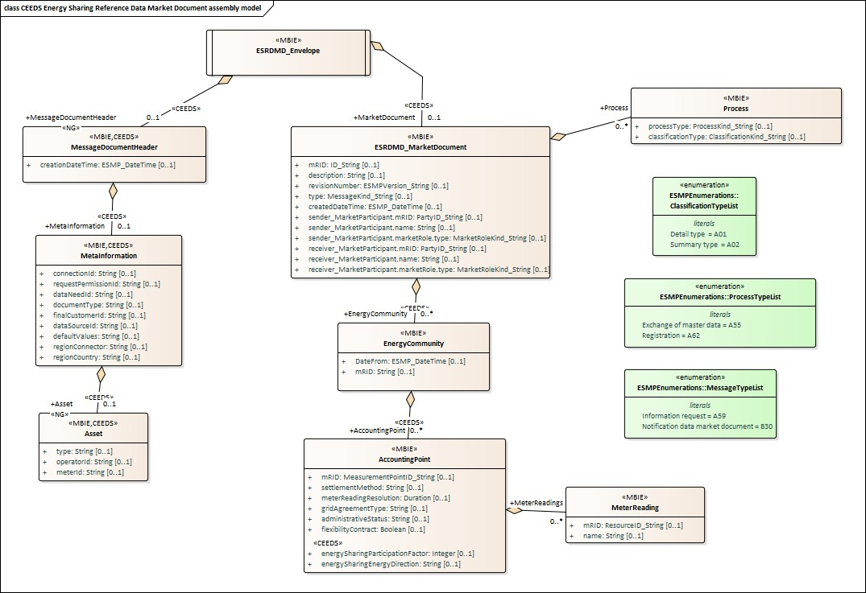

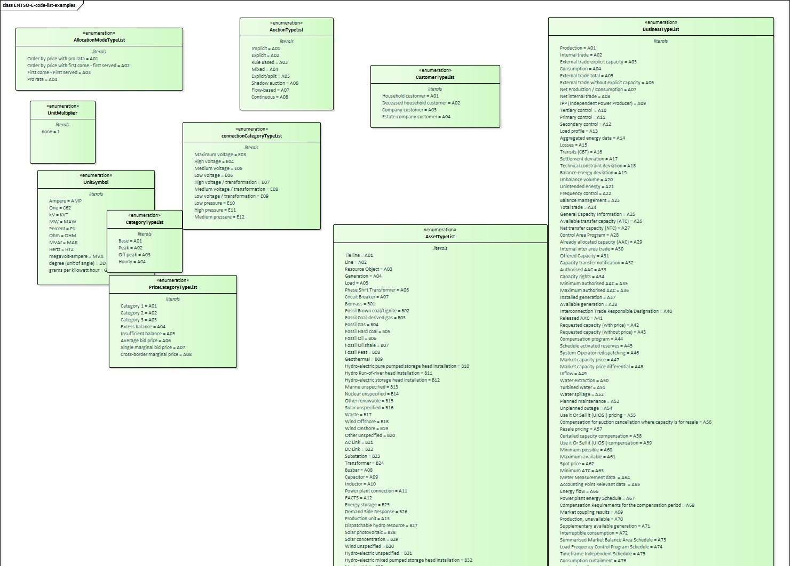

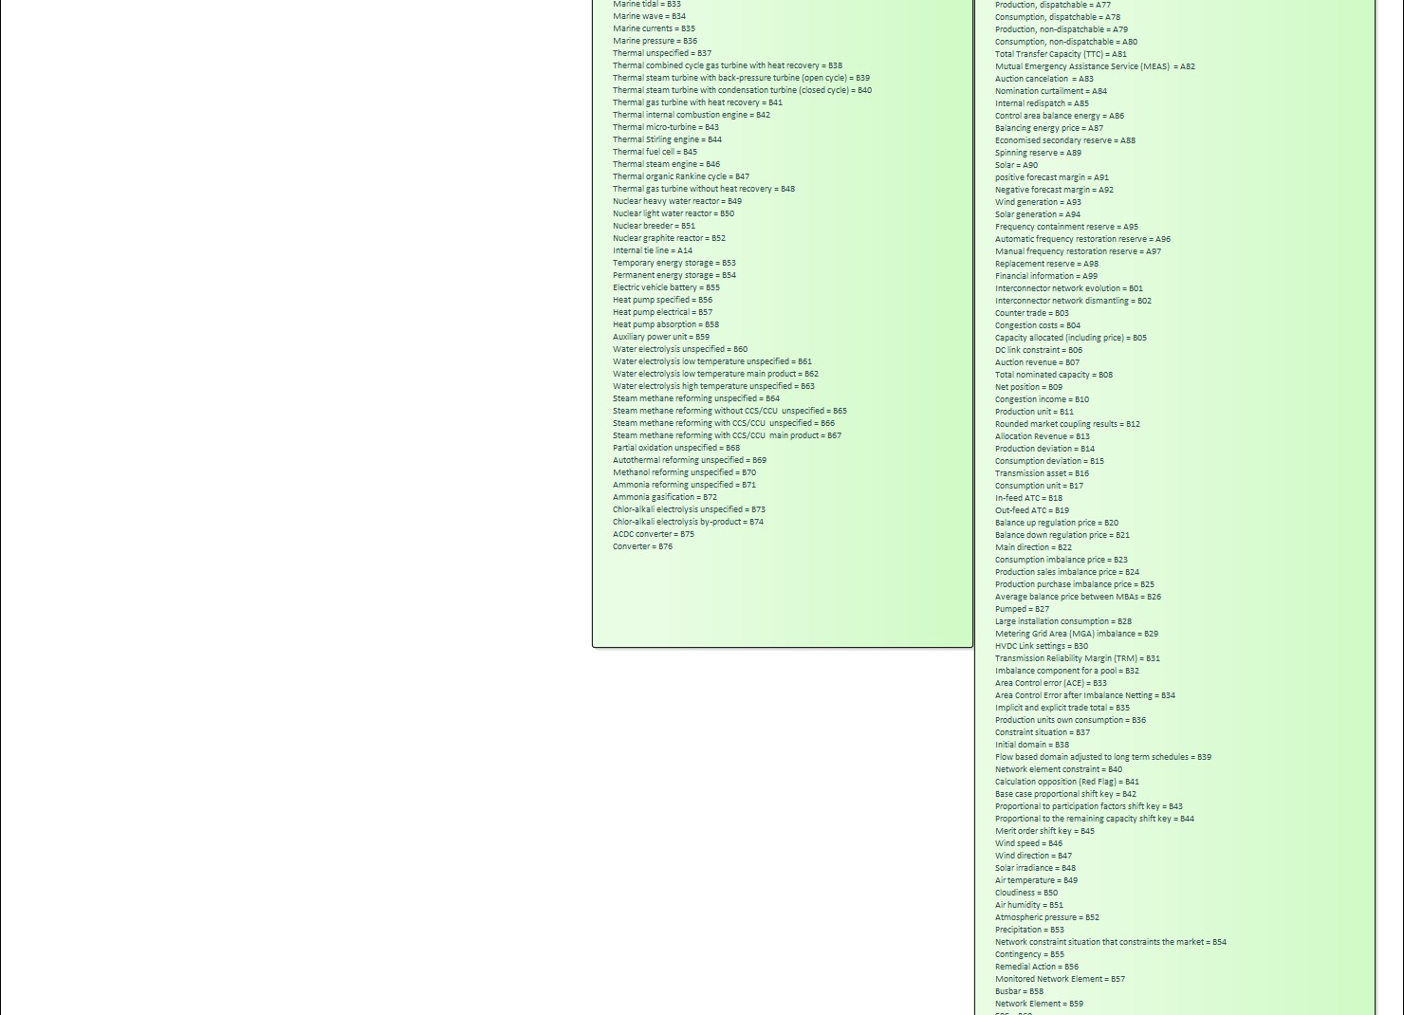





ESMPDataTypes_ESMPCompound.png %d×%d pixels
